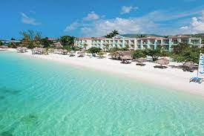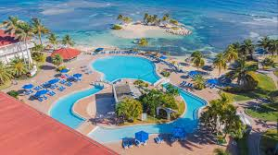

Travel With MOM
Montego Bay, Jamaica
October 12 - 19, 2024

Trip Includes:
-Roundtrip Airfare
-ALL INCLUSIVE Deluxe Hotel Accommodations
-13 Bars, 8 Restaurants and Specialty Restaurants to include.
-Steakhouse, Mexican, Indian and Grilled Barbeque Cuisine
- All Meals and Drinks
-Transfer Fees paid between the Airport and Hotel
-Different Shows every night

PRICES PER PERSON:
Garden View Ocean View Ocean View Suite
Double $2,359.00 Double $2,489.00 Double $2,659.00
Single $3,154.00 Single $3,284.00 Single $3,454.00

Suggested Payment Schedule:
Deposit of $200 due September 9, 2023
2nd Payment of $300 due November 15, 2023
3rd Payment of $250 due January 15, 2024
4th Payment of $250 due March 18, 2024
Balance due June 3, 2024

**$200 Deposit is non-refundable after November 5, 2023**
For More Information Contact: MAKE AND MAIL CHECKS OR MONEY ORDERS TO:
202-723-5852 Cell 202-288-1680 TRAVEL WITH MOM
beblessed48@aol.com PO BOX 1623 WASHINGTON, DC 20013
Website: http://www.travelwithmom.com ZELLE -202-288-1680 (M&T BANK)
__________________________________________________________________________________________________________________
RESPONSIBILITY: TRAVEL WITH MOM(TWM) ASSUMES NO LIABILITY FOR , AND THE PESSENGER AGREES THAT (TWM) SHALL NOT BE RESPONSIBLE OR LIABLE FOR ANY WAVIERS OR CLAIMS AGAINST THEM ARISING OUT OF (A) ANY DAMAGE, ACCIDENT, OR INJURY WHICH RESULTS FROM, OR OCCASIONED BY AND DEFECT OR ACTS OR FAILURE TO ACT OF ANY TRANSPORTATION COMPANY IN CONVEYING THE PASSENGER, MECHANICAL FAILURES, OR STRIKES AFFECTING THE TRANSPORTATION OR (B) ANY OTHER CAUSE OR FACTOR, OF WHATEVER NATURE BEYOND TRAVEL WITH MOM CONTROL $30.00 CHARGE FOR ALL RETURNED CHECKS. RATES ARE BASED ON CURRENT AIRFARE SUBJECT TO A FUEL SURCHARGE.
________________________________________________________________ ____________________________________________________

Return this portion with your deposit Montego Bay, Jamaica Room Type: ________________________

Name_________________________________________________________DOB: ________________________
Address _______________________________________ _____________________________________________
Phone __________________________ Email Address: _______________________________________________

Roommate(s) ______________________________DOB: ___________________Email: ____________________

